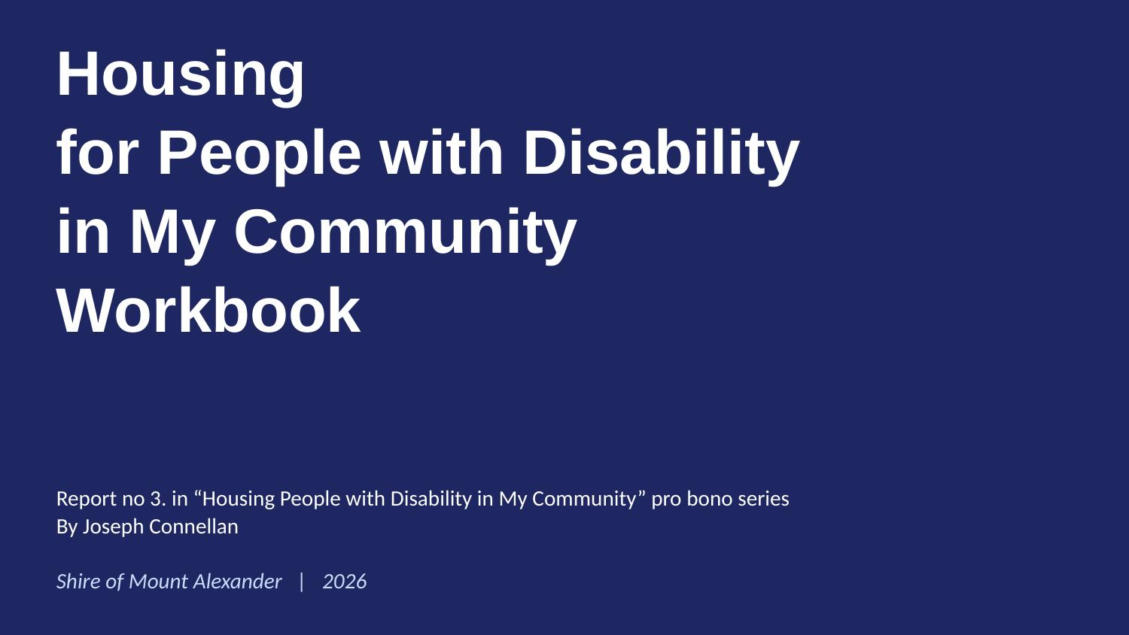
Joseph Connellan · joseph.connellan@gmail.com · 0438 388 444 · www.josephconnellan.com

SLIDE 2 OF 22
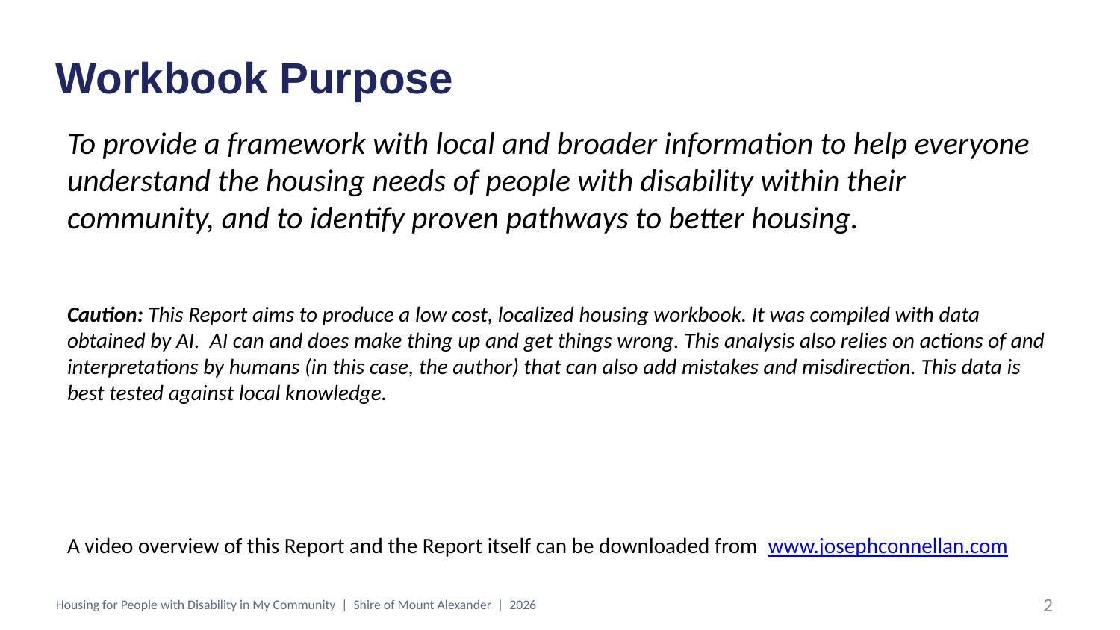
Comments
Type here…

Questions
Type here…

Links on this slide
• Joseph Connellan (author's website)

SLIDE 3 OF 22
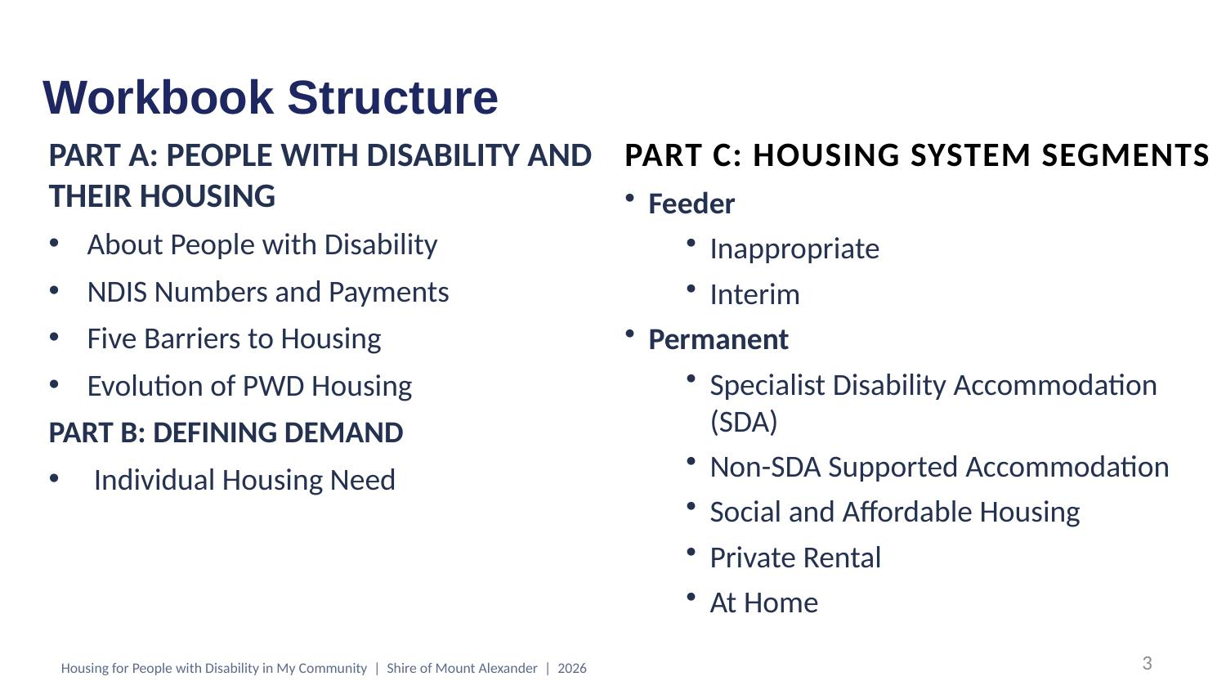
Comments
Type here…

Questions
Type here…

SLIDE 4 OF 22
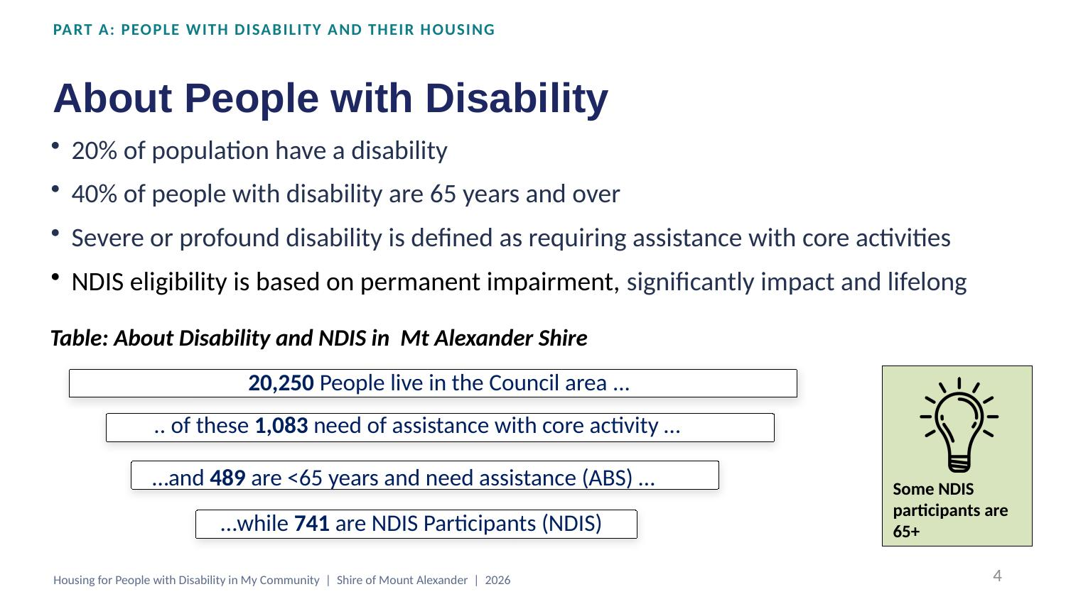
Comments
Type here…

Questions
Type here…

Links on this slide
• National Disability Insurance Scheme (NDIS)
• Australian Bureau of Statistics (ABS)

SLIDE 5 OF 22
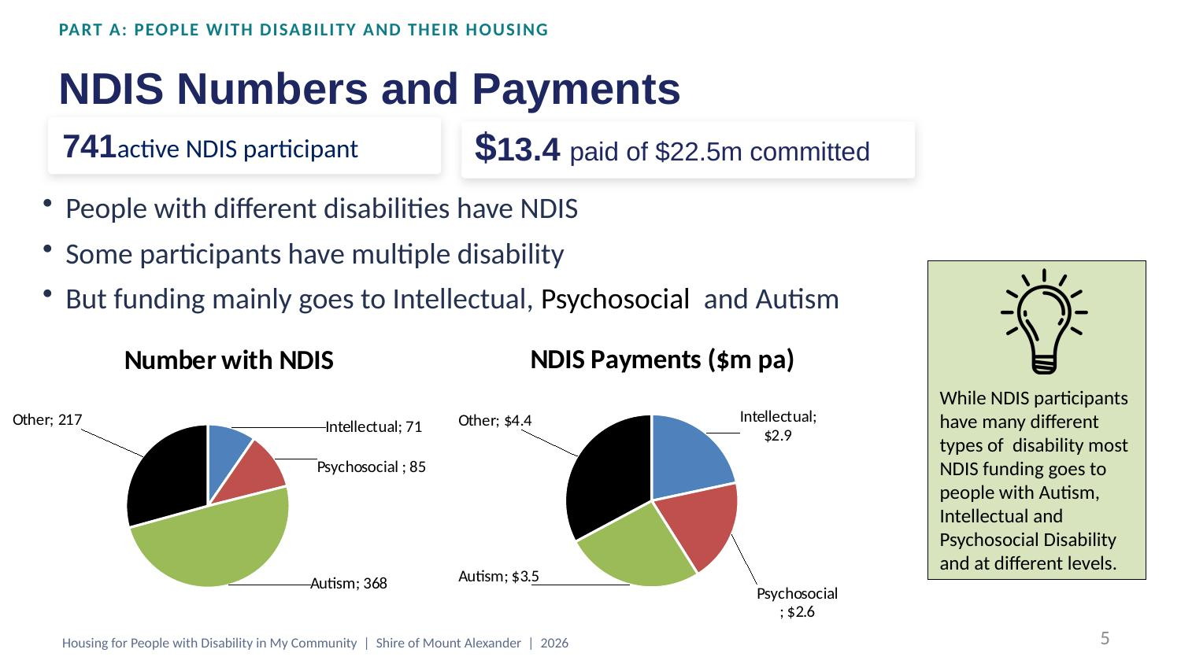
Comments
Type here…

Questions
Type here…

Links on this slide
• NDIS — participant data

SLIDE 6 OF 22
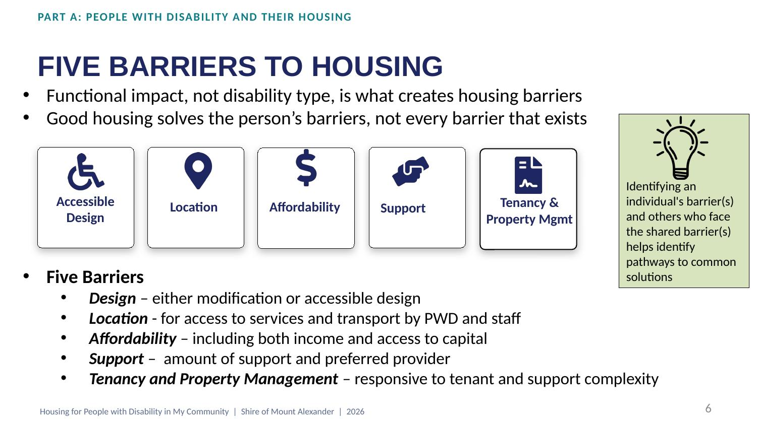
Comments
Type here…

Questions
Type here…

SLIDE 7 OF 22
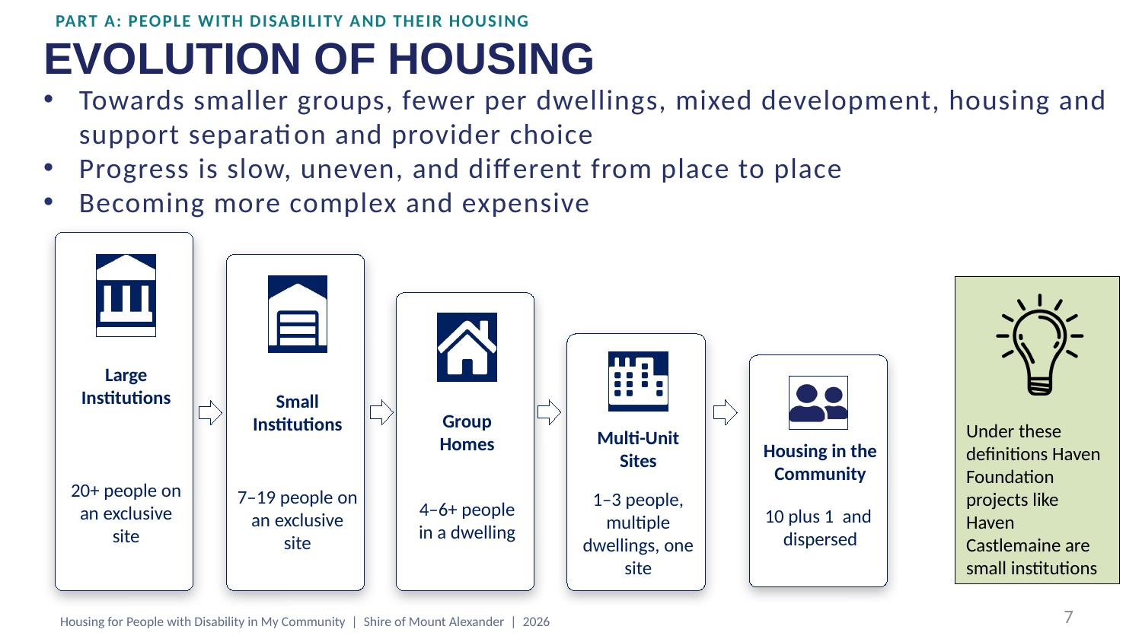
Comments
Type here…

Questions
Type here…

Links on this slide
• The Haven Foundation (Mind Australia)

SLIDE 8 OF 22
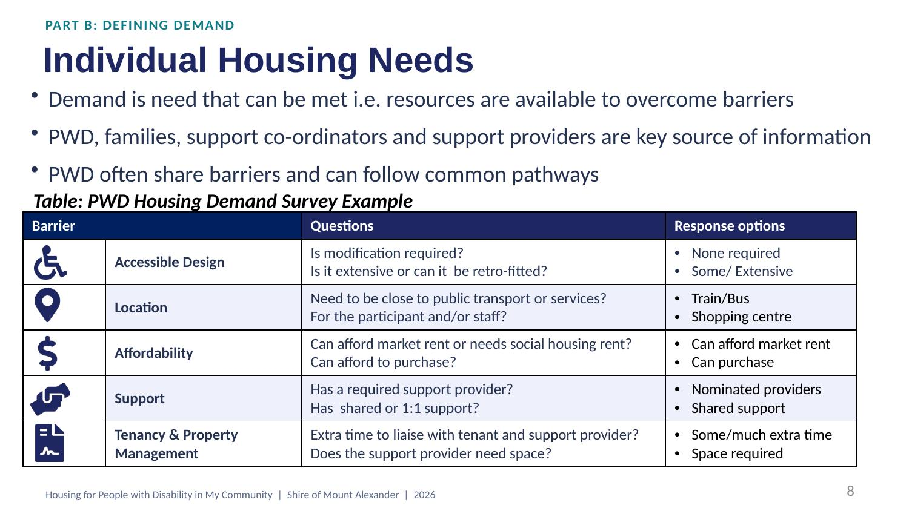
Comments
Type here…

Questions
Type here…

SLIDE 9 OF 22
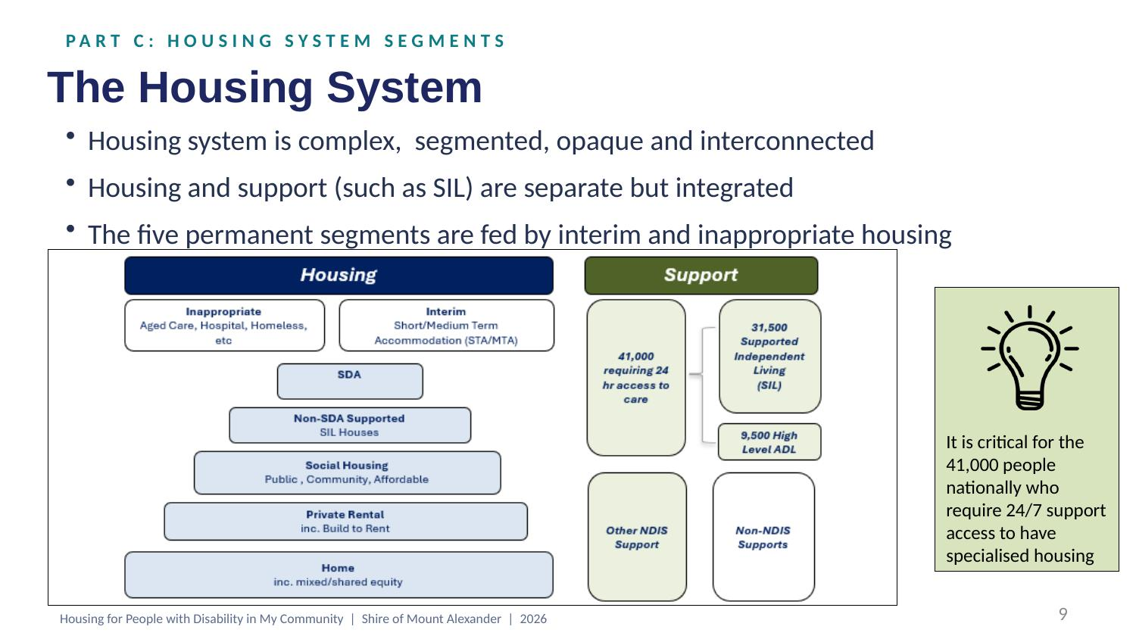
Comments
Type here…

Questions
Type here…

Links on this slide
• Supported Independent Living (SIL) — NDIS

SLIDE 10 OF 22
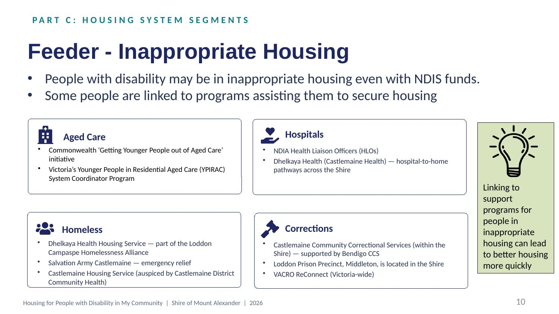
Comments
Type here…

Questions
Type here…

Links on this slide
• Commonwealth 'Younger People in Residential Aged Care' initiative | • Loddon Campaspe Homelessness Alliance
• YPIRAC System Coordinator Program (Ability First Australia) | • Salvation Army — Castlemaine Corps
• NDIS Health Liaison Officers | • Corrections Victoria — Community Correctional Services
• Dhelkaya Health (Castlemaine Health) | • Loddon Prison Precinct
• Dhelkaya Health — Housing Services | • VACRO — ReConnect

SLIDE 11 OF 22
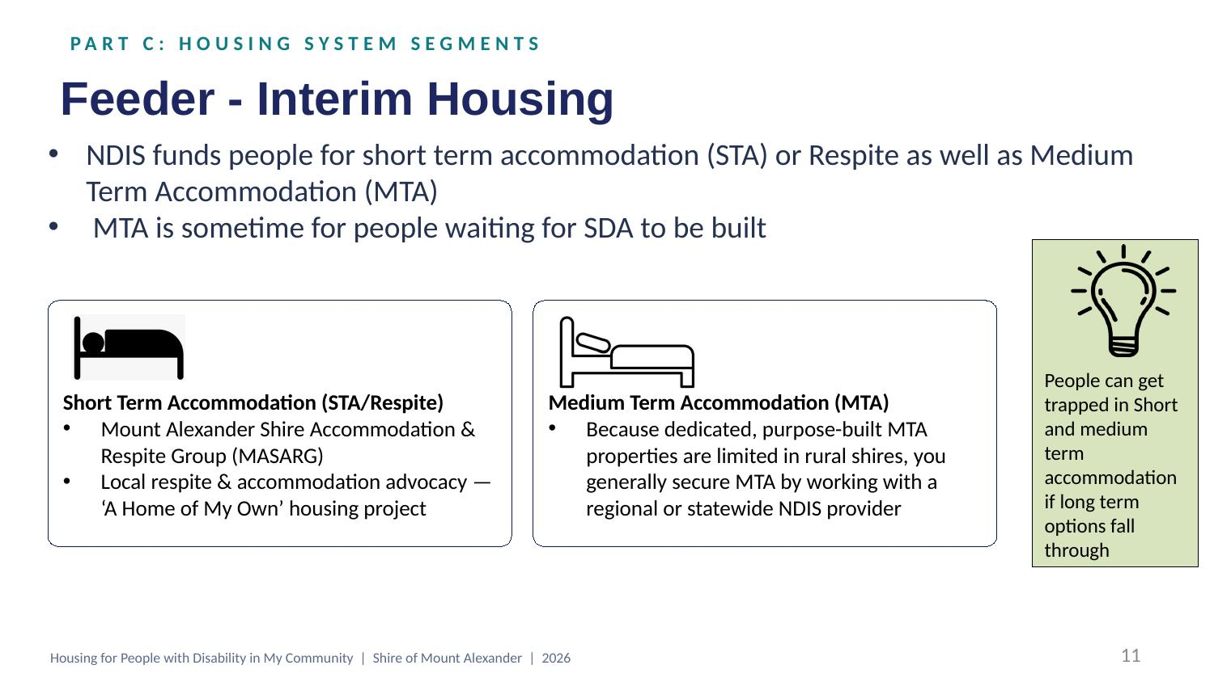
Comments
Type here…

Questions
Type here…

Links on this slide
• NDIS Short Term Accommodation (STA / Respite)
• NDIS Medium Term Accommodation (MTA)
• Mount Alexander Shire Council

SLIDE 12 OF 22
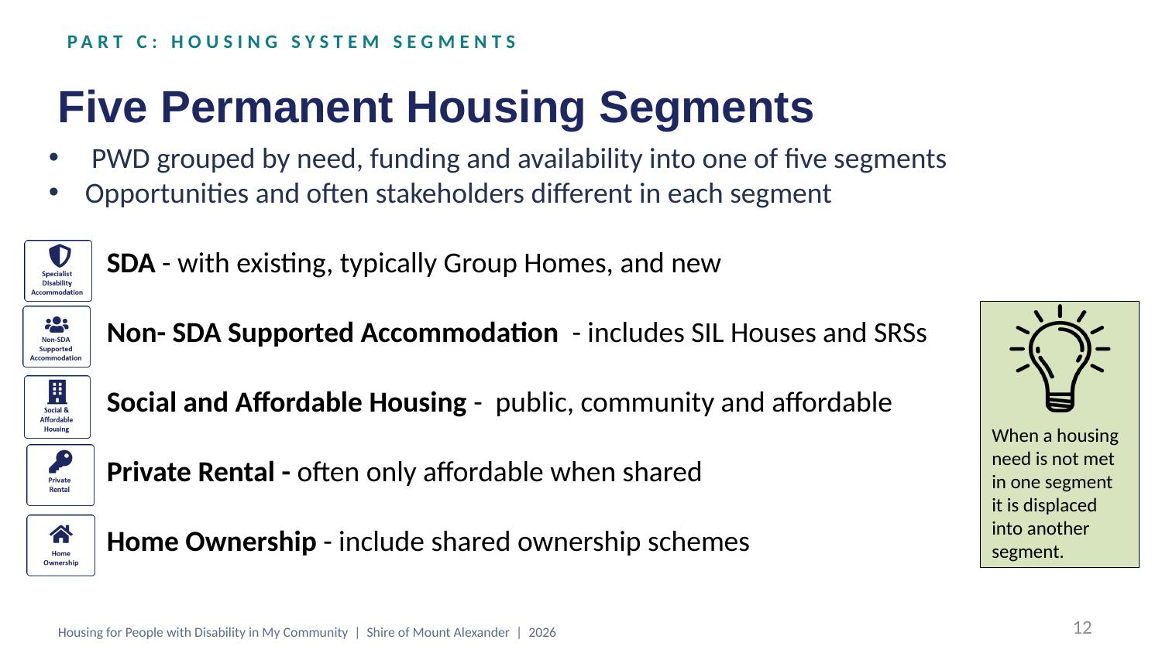
Comments
Type here…

Questions
Type here…

SLIDE 13 OF 22
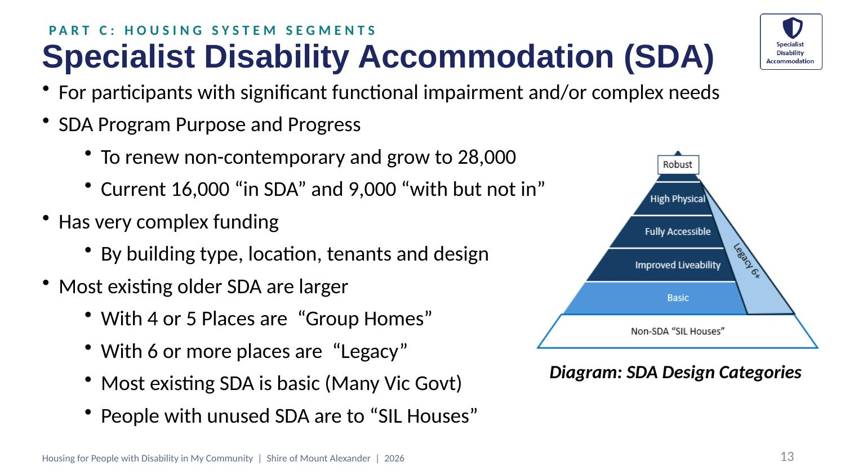
Comments
Type here…

Questions
Type here…

Links on this slide
• Specialist Disability Accommodation (SDA) — NDIS
• SDA Design Standard

SLIDE 14 OF 22
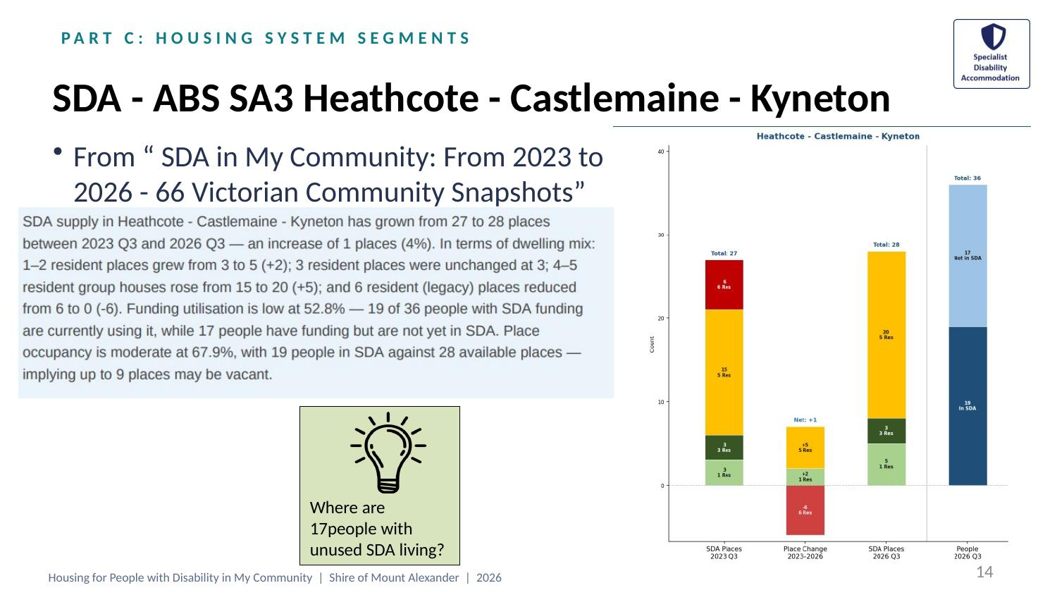
Comments
Type here…

Questions
Type here…

Links on this slide
• SDA in My Community — 66 Victorian Community Snapshots
• NDIS SDA Vacancy Finder

SLIDE 15 OF 22
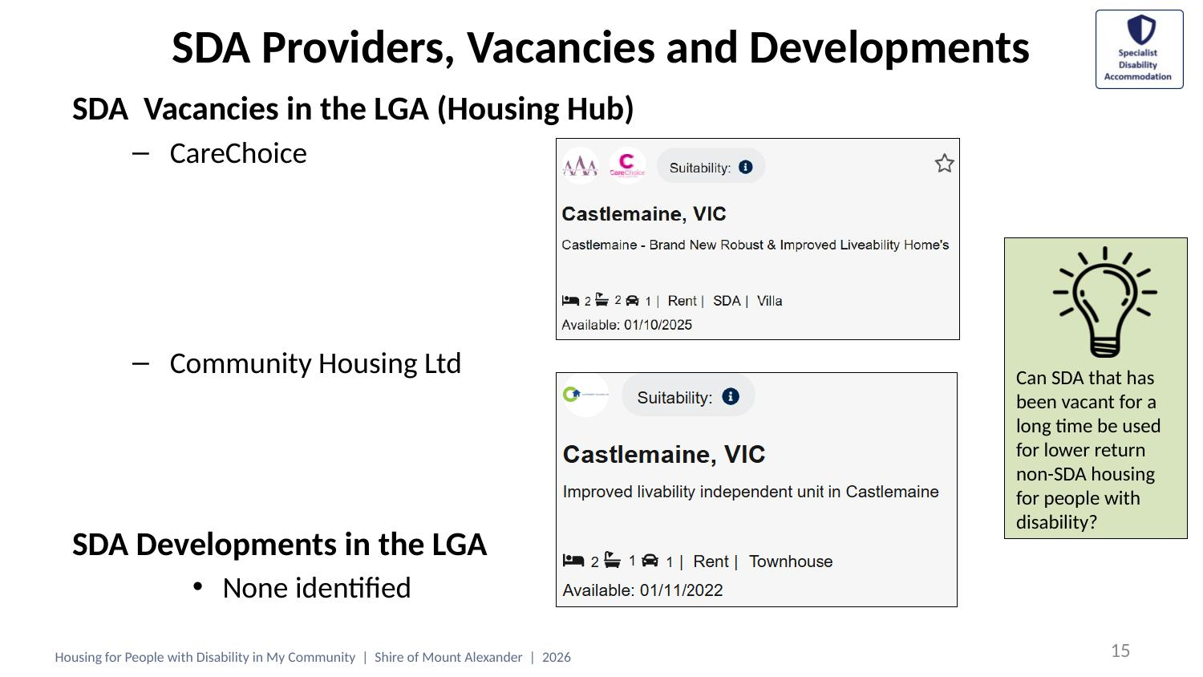
Comments
Type here…

Questions
Type here…

Links on this slide
• Housing Hub — SDA vacancies
• CareChoice
• Community Housing Limited (CHL)

SLIDE 16 OF 22
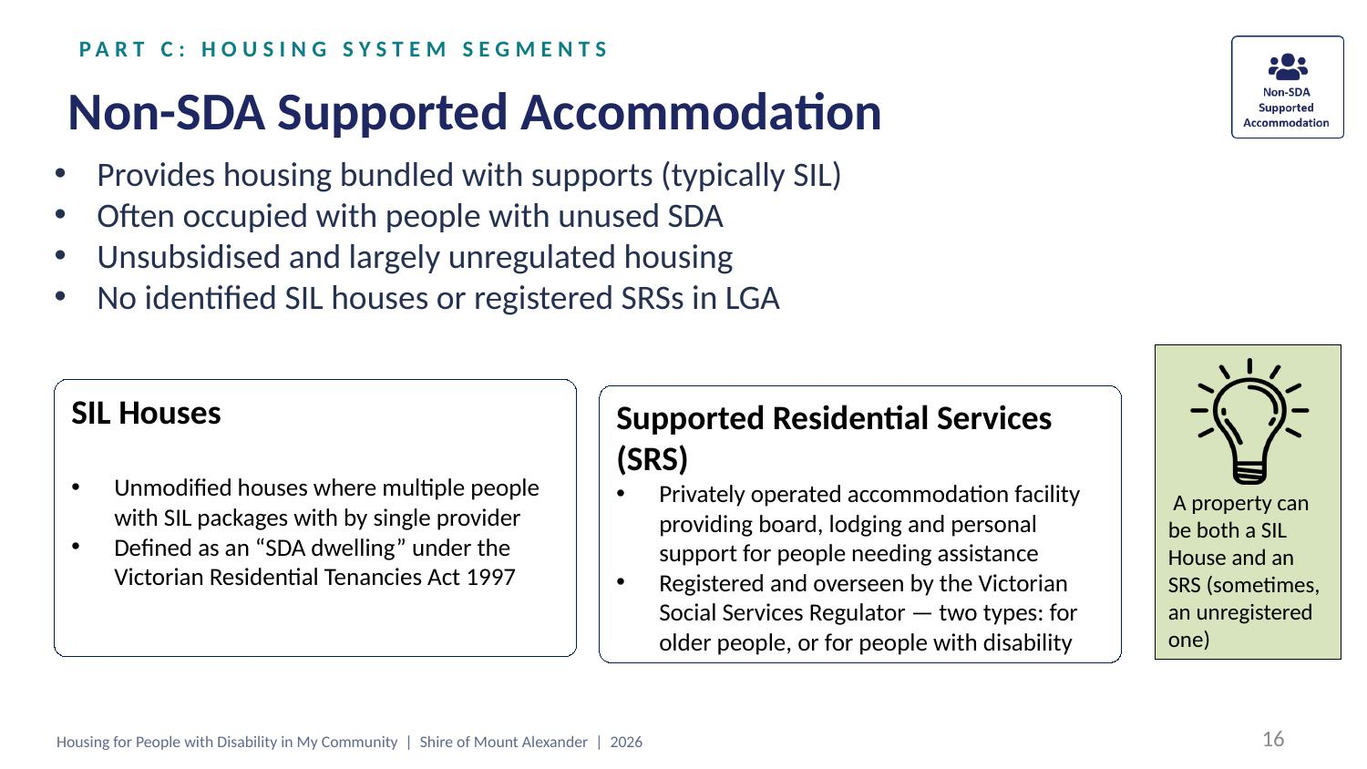
Comments
Type here…

Questions
Type here…

Links on this slide
• Residential Tenancies Act 1997 (Vic)
• Social Services Regulator (Victoria)
• Supported Residential Services (SRS)

SLIDE 17 OF 22
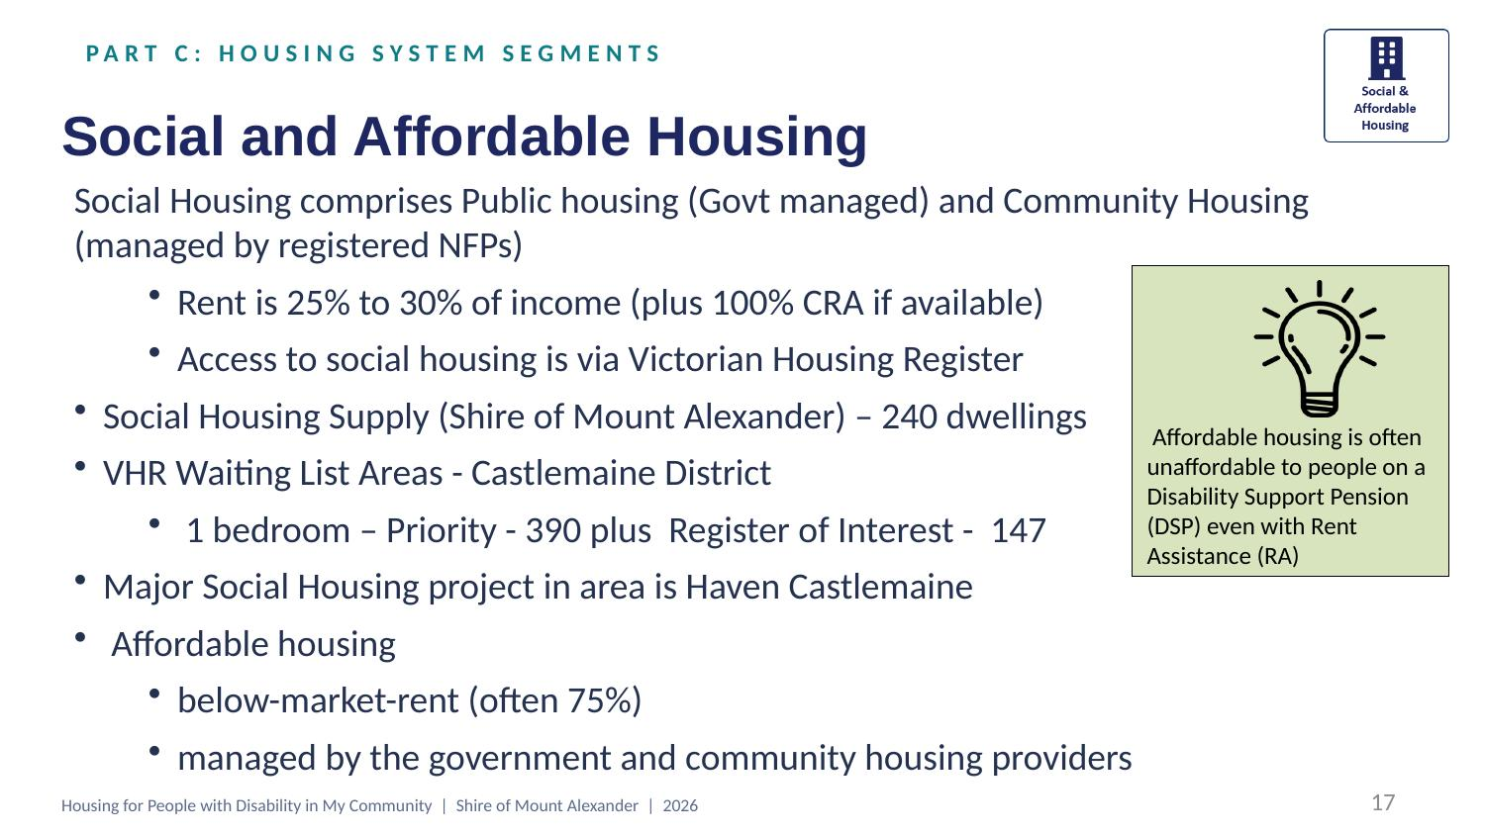
Comments
Type here…

Questions
Type here…

Links on this slide
• Housing Victoria | • Commonwealth Rent Assistance (CRA) — Services Australia
• Victorian Housing Register (VHR) | • Disability Support Pension (DSP) — Services Australia
• Homes Victoria | • Haven Castlemaine (Mind Australia)

SLIDE 18 OF 22
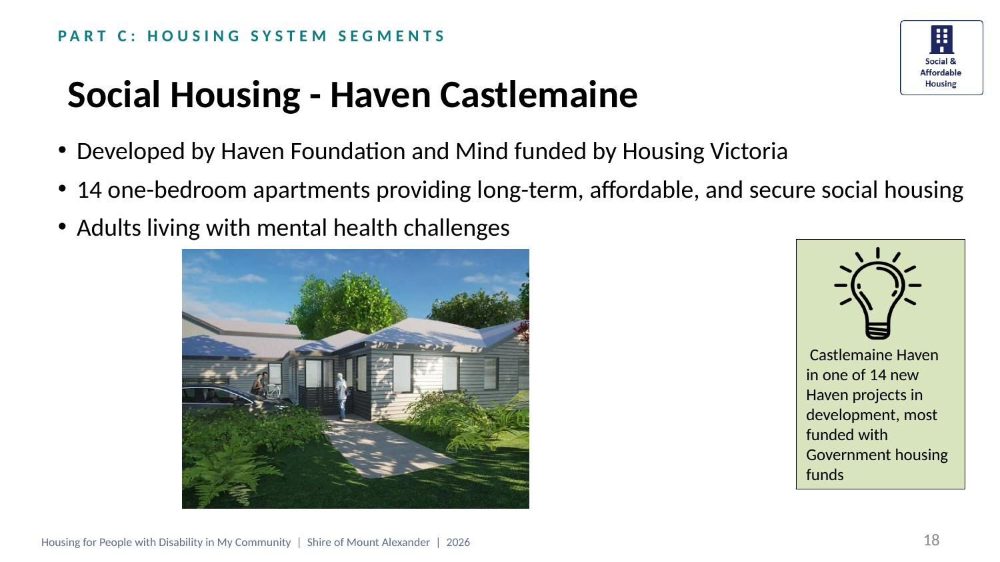
Comments
Type here…

Questions
Type here…

Links on this slide
• Mind Australia
• The Haven Foundation
• Homes Victoria — Big Housing Build

SLIDE 19 OF 22
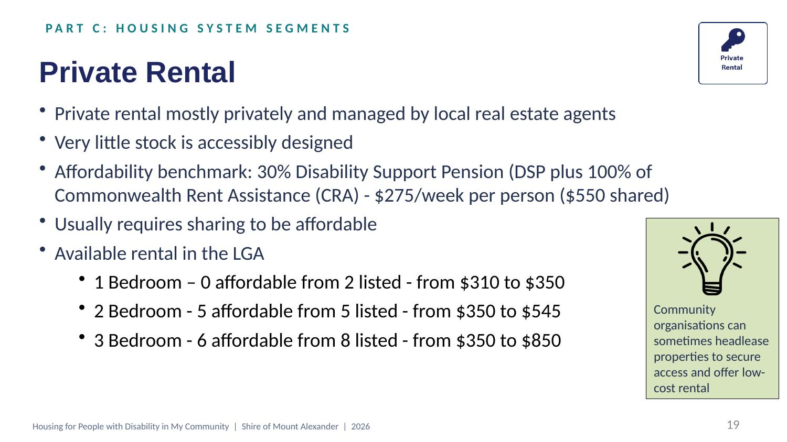
Comments
Type here…

Questions
Type here…

Links on this slide
• Disability Support Pension (DSP) — Services Australia
• Commonwealth Rent Assistance (CRA) — Services Australia

SLIDE 20 OF 22
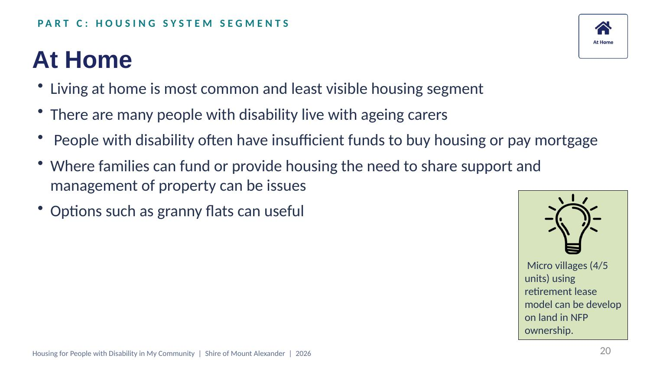
Comments
Type here…

Questions
Type here…

SLIDE 21 OF 22
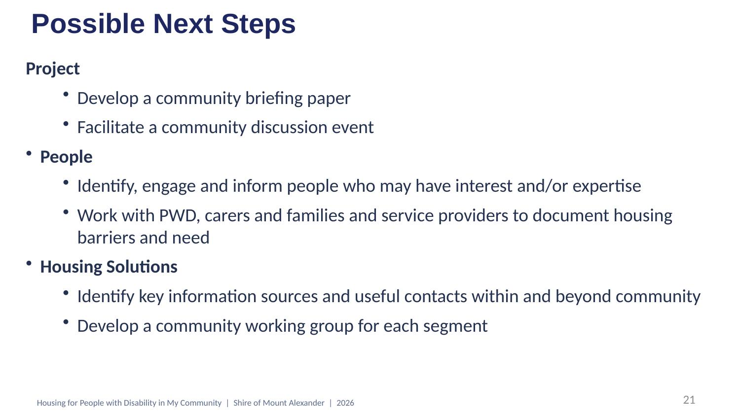
Comments
Type here…

Questions
Type here…

SLIDE 22 OF 22
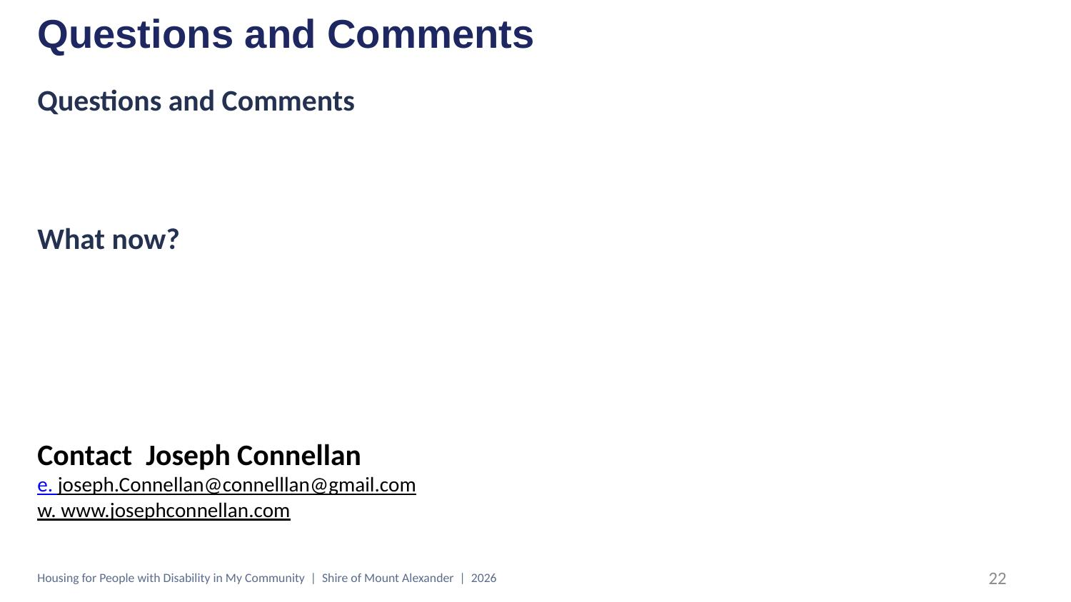
Comments
Type here…

Questions
Type here…

Links on this slide
• Contact Joseph Connellan

